* **Define and describe an inner join, then give an example of the SQL.** The inner join Selects the two table’s rows when the ON statement is true.

***(Mohanty)***

* **Define and describe a left join, then give an example of the SQL**. The Left join selects the content of the ‘left table’ even if it does not have values that match the ‘right table’

***(Mohanty)***

* Define and describe a right join, then give an example of the SQL The Right join selects the content of the ‘right table’ even if it does not have values that match the ‘left table’

***(Mohanty)***

* **Define and describe a Union, then give an example of the SQL**. Unions adds the contents of two tables into a single column.

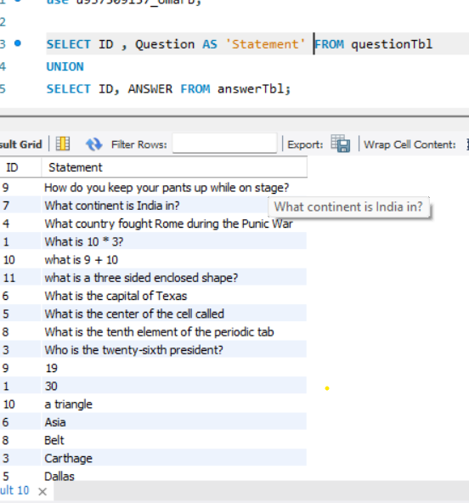

* **Which Join do you think you will be using the most in your average database and why**? I would use INNNER JOIN the most because when I am making tables, I am making them so they can complement each other.
* **Which Join do you like the best and why?** I like INNER JOIN the most because there isn’t gaps in the data.

Source

Mohanty, Ulka. “SQL Joins Explained |¦| Joins in SQL |¦| SQL Tutorial.” *Www.youtube.com*, 2019, www.youtube.com/watch?v=9yeOJ0ZMUYw&t=246s. Accessed 5 Nov. 2022.